November 5th, 2006
Hi
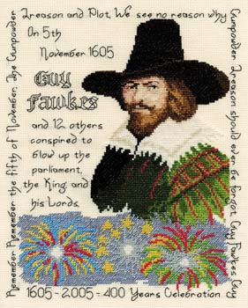
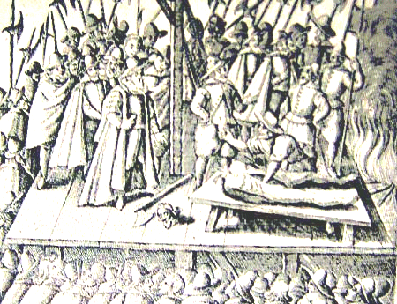
Not much to write about. Today is ‘Guy Fawkes day’, the 401st anniversary of the day when Guy Fawkes and his Catholic co-conspirators were caught while trying to blow up the English parliament with the protestant King James I present. He was executed soon after, as shown in the drawing. Bonfires used to be lit on this day, in NZ as well. Don’t know if they still are. I remember that in Gisborne there used to be a huge bonfire at the beach along with everyone letting off fireworks. I also remember when Uncle Bruce was badly burnt. Someone had lit a ‘sparkler’ and then thrown it into the air. Unfortunately, it came right down onto Uncle Bruce, down his shirt and lodged on his stomach where it continued to burn. He got a very bad burn. (BTW, discovered on the Internet that a ‘bonfire’ was originally a ‘bone-fire’ as animal bones used to be added to fire along with the wood.)
Talking about anniversaries, it now the third year since Gavin’s accident.
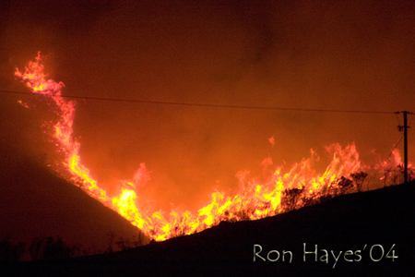
In Hong Kong, one of the territory’s big tycoons died last Sunday. He was Henry Fok; I don’t know if you have heard of him. He was very close to the leadership in China. He became close during the Korean War when he disregarded the boycott on sending arms to China or North Korea.
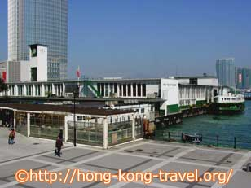
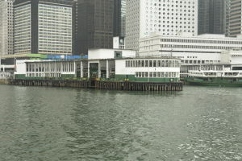
Last Monday was a public holiday for the Chung Yuen (grave-sweeping) festival. And, as everyone can predict, there were hill fires - more than 60 all together. One fire in the Tai Lam Country Park (where Leonie and I went running) was finally extinguished after burning for 2 days and destroying more than 66 000 trees, It was the worst hill fire for 10 years and it is estimated that it will take up to 20 years for it to grow back – just in time for another fire (as a cartoon in the SCMP showed it)!
Next weekend, the Star Ferry Pier on HK side and the nearby Queen’s Pier are to close in readiness for demolition. A new Star Ferry pier has been constructed about 400 metres away.
I have not done any exercise for the past 11 days. Just too exhausted! I may start again tomorrow. I would like to begin hikes/runs next Saturday.

Close to remembrance days; next Sunday in the UK and HK and Saturday (11th) in the US. You know it is close when you see, on the TV news, people in the UK wearing poppies.
The ABs play England later today. Yesterday Australia and Wales played to a draw in Cardiff.
That’s about it for now.

Cheers

